Output & Screenshots:

1. Deploying the VPC for EKS Cluster:

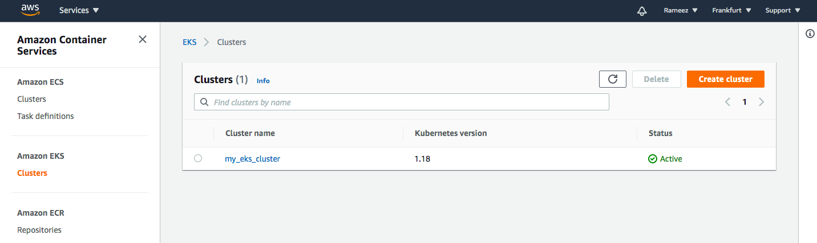

1. Once we deploy the Terraform codes we get the below in AWS console.

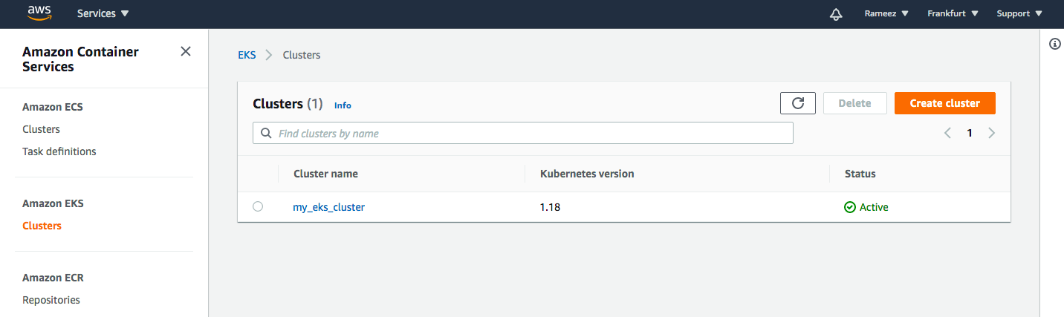

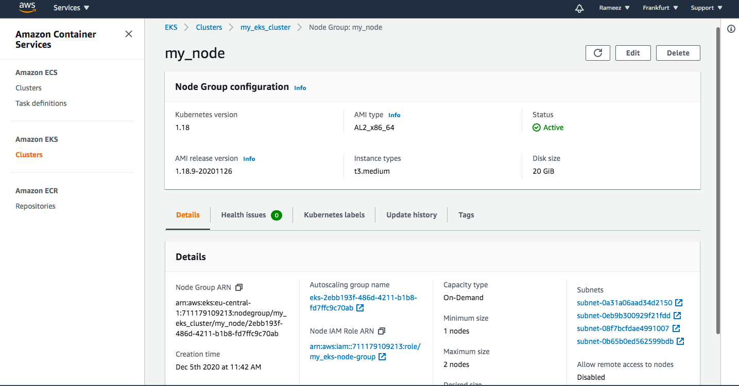

1. You can also see your node running as below.



1. Now we will use the helloworld pod and service definition file to deploy the POD and service once done we can use the hostname to access the HelloWorld Application in any browser which will look like below,

